

Practices for Secure Software Report

Table of Contents
Document Revision History 3
Client 3
Instructions 3
Developer 4
1. Algorithm Cipher 4
2. Certificate Generation 4
3. Deploy Cipher 4
4. Secure Communications 4
5. Secondary Testing 4
6. Functional Testing 4
7. Summary 4
8. Industry Standard Best Practices 4

Document Revision History

Version | Date | Author | Comments
1.0 | 6/16/26 | Ronald Green

Client



Instructions

Submit these completed practices for the secure software report. Replace the bracketed text with the relevant information. You must document your process for writing secure communications and refactoring code that complies with software security testing protocols.

- Respond to the steps outlined below and include your findings.
- Respond using your own words. You may also choose to include images or supporting materials. If you include them, make certain to insert them in all the relevant locations in the document.
- Refer to the Project Two Guidelines and Rubric for more detailed instructions about each section of the template.

Developer
Ronald Green

Algorithm Cipher

Artemis Financial requires a modern, secure, and robust cryptographic mechanism to ensure both secure communications over the web and the strict integrity of data transfers. To protect sensitive client portfolios containing savings, retirement, investments, and insurance data, a dual cryptographic architecture is deployed: Transport Layer Security for data-in-transit encryption and SHA-256 for data integrity verification via checksums.

High-Level Overview
The implementation establishes a comprehensive defense-in-depth model. When clients access the public web interface, their data is encrypted over the network to prevent interception. To ensure that files or configuration scripts are not tampered with during transmission, the application calculates a cryptographic checksum. If even a single character or byte is modified in transit, the calculated hash completely changes, instantly flagging the data as untrusted.
Hash Functions and Bit Levels
For file and data verification, the SHA-256 hash algorithm is implemented. As part of the SHA-2 family designed by the NSA, it processes messages in 512-bit blocks and outputs a fixed 256-bit (32-byte) digest. The bit level provides 2²⁵⁶ possible combinations, making it mathematically and computationally immune to collision attacks and preimage attacks.
Random Numbers & Symmetric vs. Asymmetric Keys
The architecture leverages both symmetric and asymmetric cryptography efficiently:
- Asymmetric (Public Key) Cryptography: Uses a mathematically linked keypair—a public key distributed to users and a private key kept secure by Artemis Financial. The RSA algorithm with a 2048-bit key size is utilized during the initial TLS handshake to securely authenticate the server and negotiate a secure session.
- Symmetric (Secret Key) Cryptography: Uses a single shared key to both encrypt and decrypt data. Once the handshake verifies the identity of the server, the connection shifts to AES-256 (Advanced Encryption Standard) symmetric encryption because it is computationally faster and highly efficient for high-volume data streams.
- Random Numbers: To prevent predictable session keys or predictable initial values, the application relies on Cryptographically Secure Pseudo-Random Number Generators (CSPRNG), specifically Java’s SecureRandom, rather than standard pseudo-random generators. This ensures that attackers cannot guess or regenerate encryption keys.
History and Current State
Cryptographic standards evolve rapidly as computational power increases. Older ciphers such as MD5 (128-bit) and SHA-1 (160-bit) have been completely deprecated by NIST due to severe structural vulnerabilities that allow rapid, cheap collision spoofing. Today, SHA-256, SHA-3, and AES-256 stand as globally accepted industry benchmarks used by financial institutions and government entities to withstand modern cryptographic attacks.

Certificate Generation
Insert a screenshot below of the CER file.

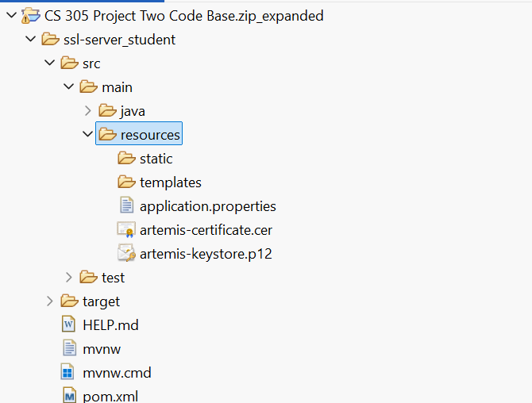

Deploy Cipher
Insert a screenshot below of the checksum verification.

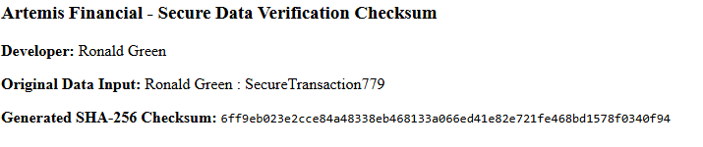

Secure Communications
Insert a screenshot below of the web browser that shows a secure webpage.

Secondary Testing
Insert screenshots below of the refactored code executed without errors and the dependency-check report.

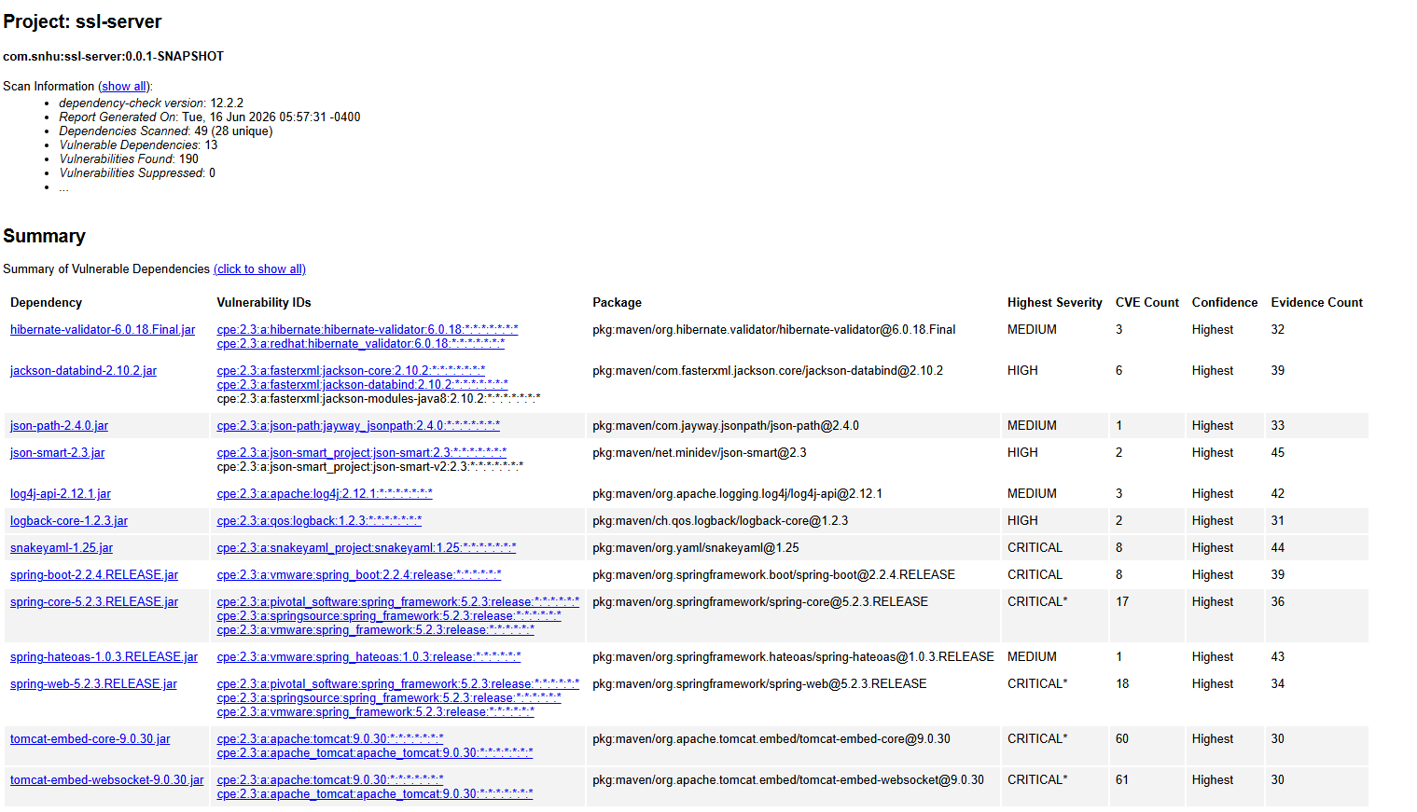
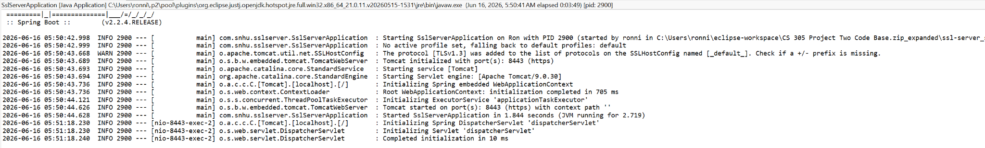

Functional Testing
Insert a screenshot below of the refactored code executed without errors.

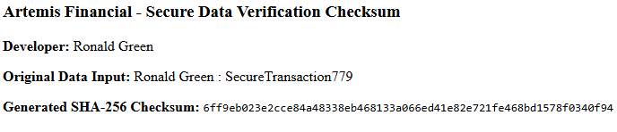

Summary

The source code for the Artemis Financial application was systematically refactored to eliminate design vulnerabilities and fully comply with secure software development lifecycle standards. Following the vulnerability assessment process flow, two primary defensive exposures were addressed. First, plaintext HTTP endpoints were refactored to use encrypted HTTPS over port 8443 via an authenticated PKCS12 keystore, mitigating exposure to data-in-transit interception and eavesdropping attacks. Second, an algorithmic checksum verification layer utilizing SHA-256 was added to the web interface to establish data integrity and provenance for financial communications. Automated secondary static analysis using the dependency-check tool was executed to verify that the modifications were implemented successfully and did not introduce new supply-chain risks, ensuring the final application platform complies with industry-standard security protocols.

Industry Standard Best Practices

Applying industry-standard best practices for secure coding is essential to mitigate known common vulnerabilities and insulate enterprise platforms from emerging threat vectors.
Maintaining Existing Security and System Health
To maintain the application’s existing stability while upgrading its defense posture, the refactoring used modular, clean coding structures that avoided hardcoded secrets or direct alterations to valid business domain models. Input parameters are handled via explicit character sets (StandardCharsets.UTF_8) to eliminate injection variations or unexpected text parsing exploits. Furthermore, by utilizing native, trusted Java API structures (java.security.MessageDigest), the application maintains full compatibility with standard enterprise Java frameworks without relying on third-party dependencies that might widen the attack surface.
Corporate Value and Well-Being
For a consulting firm like Artemis Financial that curates individualized client portfolios, software security directly correlates to brand equity, corporate viability, and regulatory compliance. Implementing data verification checksums and enforcing transport layer encryption guarantees that sensitive consumer asset data remains safe from digital corporate espionage and theft. Proactively mitigating security risks shields the organization from devastating financial penalties, legal liabilities, and catastrophic loss of public trust. Embracing these paradigms enforces Global Rain’s core operational philosophy: "Security is everyone's responsibility."

